***PAAREES PERFUMES***

***Christian Diors***

***FOR UNISEX***

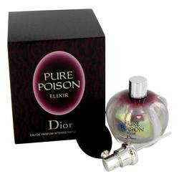

# *Pure Poison Elixir*

***Description:***

Pure Poison Elixir by Christian Dior Perfume. Pure Poison Elixir was introduced by the design house of Christian Dior in 2006. This feminine floral fragrance is just the thing for special occasions and black-tie affairs. This sweet and spicy elixir combines the notes of cacao, jasmine and vanilla with fragrant African orange flowers and petitgrain, which makes it ideal for the woman who appreciates the glamorous side of life. Just one spray before you head out for the evening and you will turn heads the minute you walk in the room.